Phyton introduction

*In this practice we learned to use priting with phyton.*

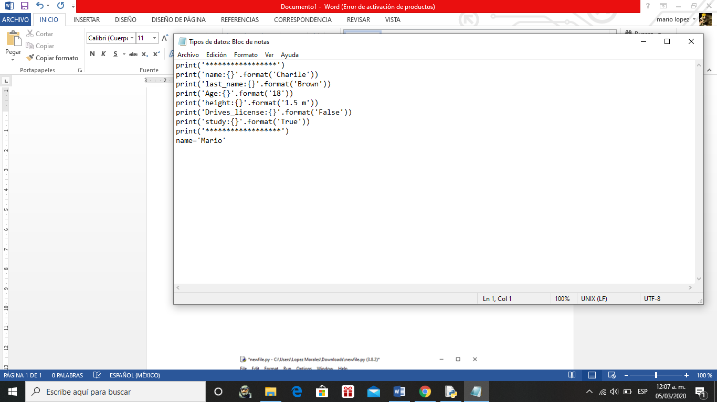

Simple AI

*In this practice create a program that changes the user’s data.*

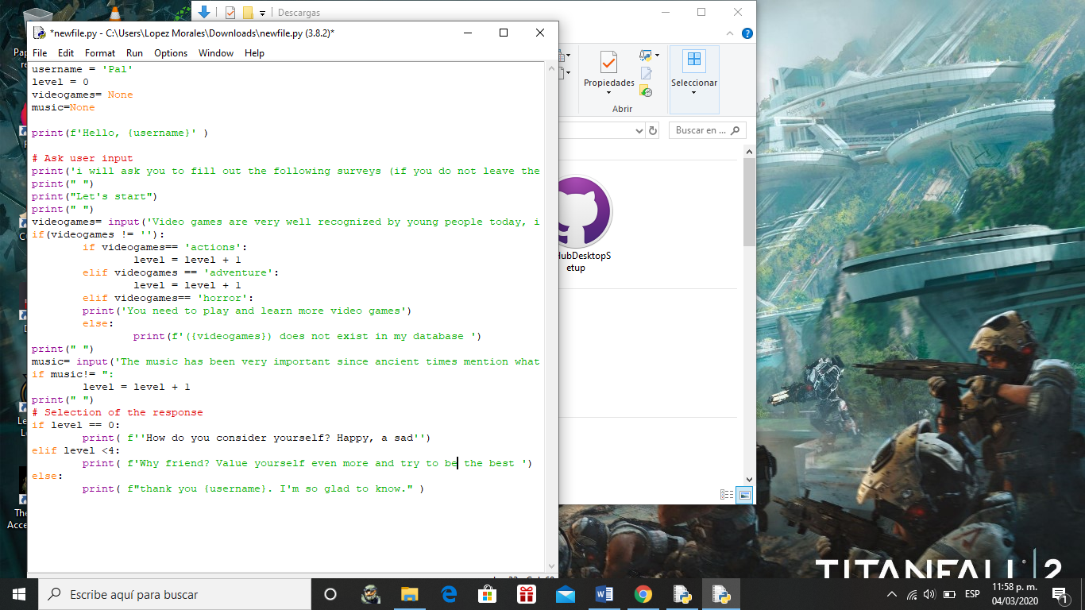

Cvs Introduction

*Created a new project in a GIT platform (GitHub) with a readme file and activates you have up to this point.*

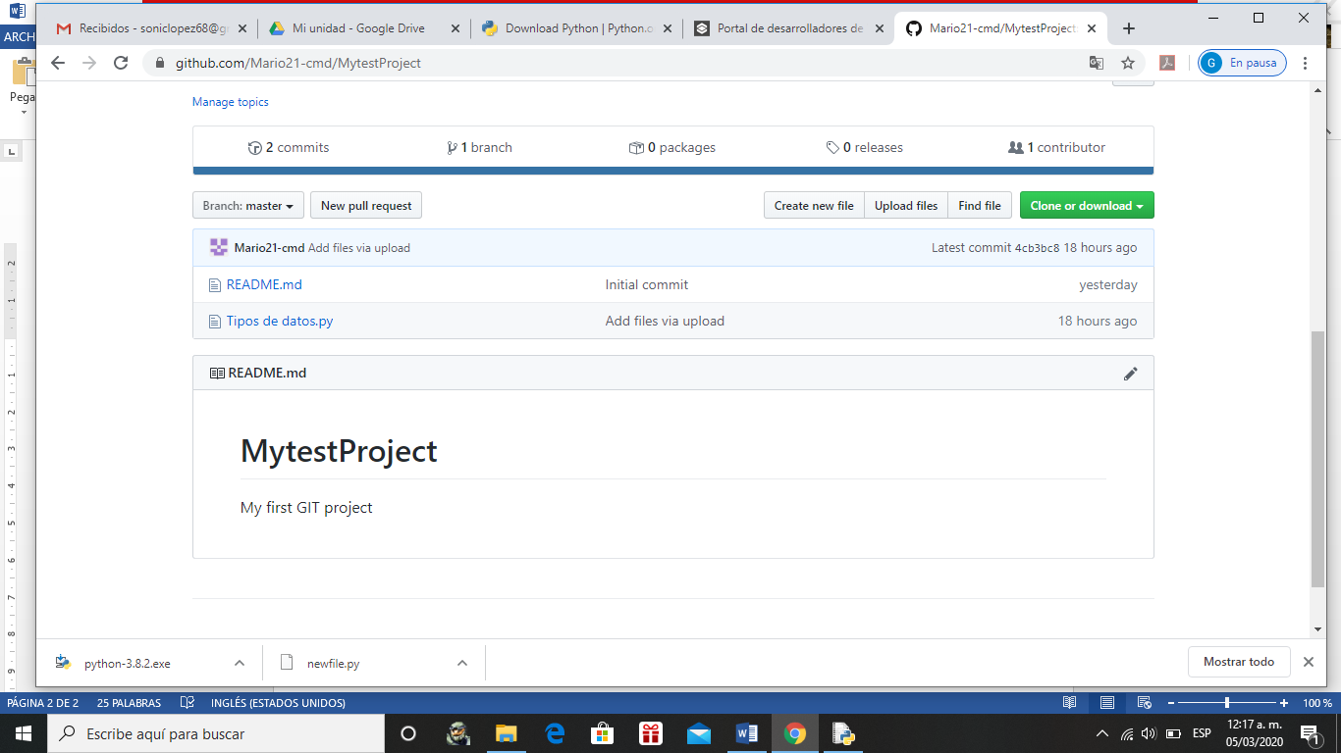

*Target creation for augmented reality*

*Design a simple AR application mockup. The marker will be evaluated by vuforia’s standars.*